Are you ready for what comes next? | Throughout your senior year, well-meaning people often ask about your plans after high school.  This can cause stress and anxitey as you are working to identify options that are the best FIT for you.  Your senior year is about the journey and taking time to develop your own plan for the future.  There are many post-secondary options available.  Looking at multiple options for after graduation and creating a plan A, B, & C, helps you prepare for what comes next.
College & University Options  Public Colleges: - Funded by state and local governments - Usually offer lower tuition for in-state residents - Examples: UW, WSU, WWU, CWU, EWU  Private Colleges: - Funded primarily by tuition, fees, and other private sources - Private donations can fund generous financial aid packages for students - Examples: Gonzaga, St. Martin’s  Liberal Arts Colleges: - Offer a broad base of courses in liberal arts - Literature, history, languages, math, life sciences - Most are private offering four-yr. programs - Examples: Whitman, Whitworth  For Profit Colleges: - Businesses that offer a variety of degree programs - Typically for specific careers - Tend to have higher costs and not all credits trasferrable  Special Focus Colleges: - Focused on a specific interest or student populations - Example: Cornish College of the Arts  Specialized Mission Colleges: - HBCU- Historically Black Colleges & Univ. - HSI – Hispanic-Serving Institutions - Offer programs, services and activities focused on underrepresented students - Examples: Howard University, Columbia Basin College | Community & Technical College Options  Community & Technical Colleges - Two-year colleges - Open access, more affordable - Earn certificates, associate degree and/or transfer to four-year college - Offer some bachelor degree programs - Often programs partner with industry to prepare for workforce - Examples: EvCC, Edmonds College, Bates Technical College, Lake Wash. Institute of Tech.  Training & Certificate Options  Certificate Programs - Funded by state and local governments - Usually offer lower tuition for in-state residents - Examples: Welding, Plumbing, Electrical  Internships - Interns are people involved in supervised, practical taining within an organization. - Real-life applications of skills learned - Experience a job before deciding on a career  Apprenticeships - Training program where you earn money while learning a skill/trade - Supervised by trade professional - Both classroom and on-the-job training  Military - Provides educational opportunities - Gain up to 90% tuition assistance for college courses - Technical training in 200+ skill areas  Employment - Entering the workforce after graduation - Paid, full or part-time positions
- Everett Public Schools is a participating institution in the following guaranteed admissions programs, or GAP:  - The Guaranteed Admission Program with Washington four-year, public institutions  - The Automatic Admission Partnership with Pacific Lutheran University  - The Guaranteed Admission Program with Saint Martin's University  Central Washington University  Eastern Washington University  The Evergreen State College  Pacific Lutheran University  Saint Martin's University  University of Washington Tacoma  Washington State University  Western Washington University | To qualify for the Guaranteed Admissions Program, a student must have:  - A minimum cumulative GPA of 3.0 (GPA of 3.3 for Pacific Lutheran University)  - Completed necessary College Academic Distribution Requirements (CADR) courses in high school (typically mirrors high school grad requirements)  - Completed the Family Educational Rights and Privacy Act (FERPA) Form (which is included in the student handbook, the enrollment form, or annual student information update) and provided permission to share high school student information with colleges.  If all of these are true or the student is on track to meet these criteria by high school graduation, GAP guarantees the student will be admitted to all participating institutions.
- Log into Naviance | 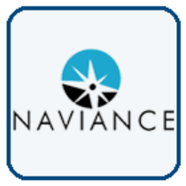  Username: district ID#  Password: district password
- Explore SuperMatch by customizing your search.  You can search over 4000 colleges from culinary, technical, 4-year, and military academies.  Click Colleges > SuperMatch College Search. Select your search criteria and BEGIN!  Remember to favorite colleges/programs to return to later. | 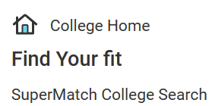  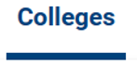  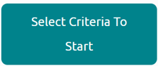
- Explore Military options by clicking on Careers > Explore Military Branches.  Click on the links to access each military branch website.  Remember to favorite the branch to return to later. |   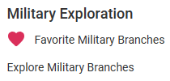  
- Explore options closer to you! Check out colleges (2-yr./4-yr./tech.), apprenticeships, certificates, etc. right in Washington.  Click the website link > Find Education > Education Type | https://careerbridge.wa.gov      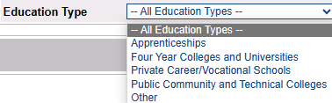
- As you explore options, all favorites will be added to your Colleges I’m Thinking About list.  Check out your favorites by clicking on Colleges tab. | 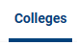  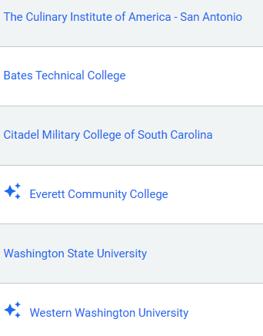
- Task Completion: | Add a minimum of 2 colleges/programs to your Colleges I’m Thinking About list in Naviance.

